|  |  |
| --- | --- |
| File:COMSATS new logo.jpg - Wikimedia Commons  Programming Fundamentals  Class Assignment 2 | **submitted by:**  **Shahzaneer Ahmed**  **registration number:**  **sp21-bcs-087**  **submitted to:**  **Mr. rizwan rashid**  **date of submission:**  **november 14, 2021** |

# Class assignment

Question 1:

Source Code:

//------------------------------------------------------------

//----------------Shahzaneer Ahmed----------------------------

//////////////////SP21-BCS-087--------------------------------

//--------------CLASS Assignment 02---------------------------

//------------------------------------------------------------

//Question – 1: ______

// Write a program that prompts the user to enter a Social Security number in the format DDD-DDDDDD, where D is a digit. Your program should check whether the input is valid. Here are

// sample runs:

// Enter a SSN: 232-23-5435

// 232-23-5435 is a valid social security number

// Enter a SSN: 23-23-5435

// 23-23-5435 is an invalid social security number

import java.util.Scanner;

public class Question1 {

public static void main(String[] args) {

Scanner input = new Scanner(System.in);

System.out.println("Enter SSN in the format DDD-DD-DDDD");

String ssn = input.nextLine();

String a = ssn.substring(0,(ssn.indexOf('-')));

String b = ssn.substring((ssn.indexOf('-')+1),(ssn.lastIndexOf('-')));

String c = ssn.substring((ssn.lastIndexOf('-')+1),(ssn.length()));

String d = a+b+c;

try {

int number = Integer.parseInt(d);

if (a.length() == 3 && b.length() == 2 && c.length() == 4)

System.out.printf("The %s is a valid social security number!", ssn);

else

System.out.printf("The %s is an invalid social security number!",ssn);

}

catch (NumberFormatException e){

System.out.printf("The %s is an invalid social security number! please enter Numbers only!",ssn);

}

}

}

Screenshot:

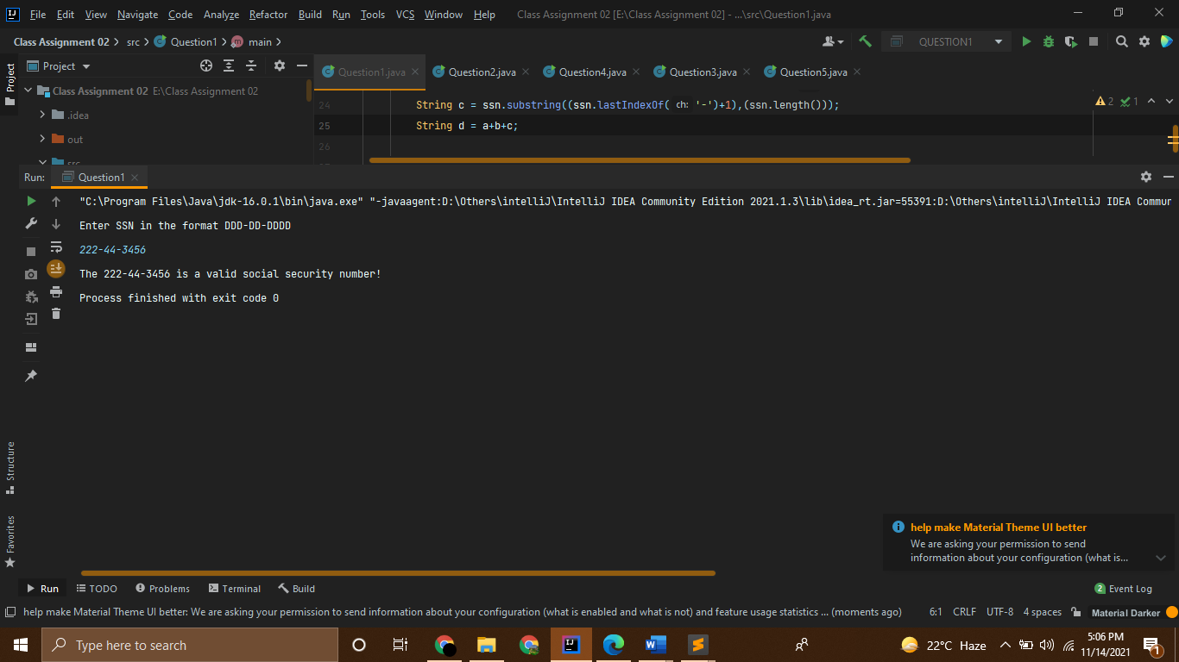

Question 2:

Source Code:

//------------------------------------------------------------

//----------------Shahzaneer Ahmed----------------------------

//////////////////SP21-BCS-087--------------------------------

//--------------CLASS Assignment 02---------------------------

//------------------------------------------------------------

//Question – 2: ______

// Write a program that prompts the user to enter two strings and reports whether the second string

// is a substring of the first string

// Enter string s1: ABCD

// Enter string s2: BC

// BC is a substring of ABCD

import java.util.Scanner;

public class Question2 {

public static void main(String[] args) {

Scanner input = new Scanner(System.in);

System.out.println("Enter String 1");

String s1 = input.nextLine();

System.out.println("Enter String 2");

String s2 = input.nextLine();

boolean a = s1.contains(s2);

if (a) System.out.println("String 1 is a substring of String 2");

else System.out.println("The String 1 is not a substring of String 2");

}

}

Screenshot:

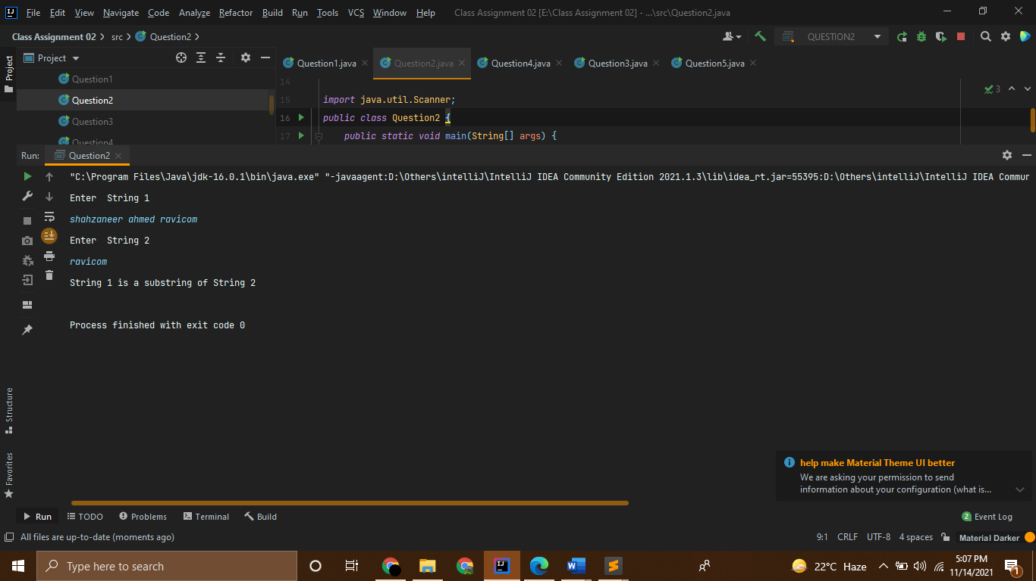

Question 3:

Source Code:

//------------------------------------------------------------

//----------------Shahzaneer Ahmed----------------------------

//////////////////SP21-BCS-087--------------------------------

//--------------CLASS Assignment 02---------------------------

//------------------------------------------------------------

//Question – 3: ______

// Assume a vehicle plate number consists of three uppercase letters followed by four digits. Write a

// program to generate a plate number.

import java.util.Random;

public class Question3 {

public static void main(String[] args) {

Random rand = new Random();

int numbers = 1000 + rand.nextInt(1000);

// System.out.println(numbers);

String alphabets = "QWERTYUIOPASDFGHJKLZXCVBNM";

String upperCaseLetters = "";

for (int i = 0; i<3;i++) {

int randomIndex = rand.nextInt(alphabets.length());

char randomChar = alphabets.charAt(randomIndex);

upperCaseLetters += randomChar;

}

// System.out.println(upperCaseLetters);

System.out.printf("The randomly generated Number plate is : %s%d",upperCaseLetters,numbers);

}

}

Screenshot:

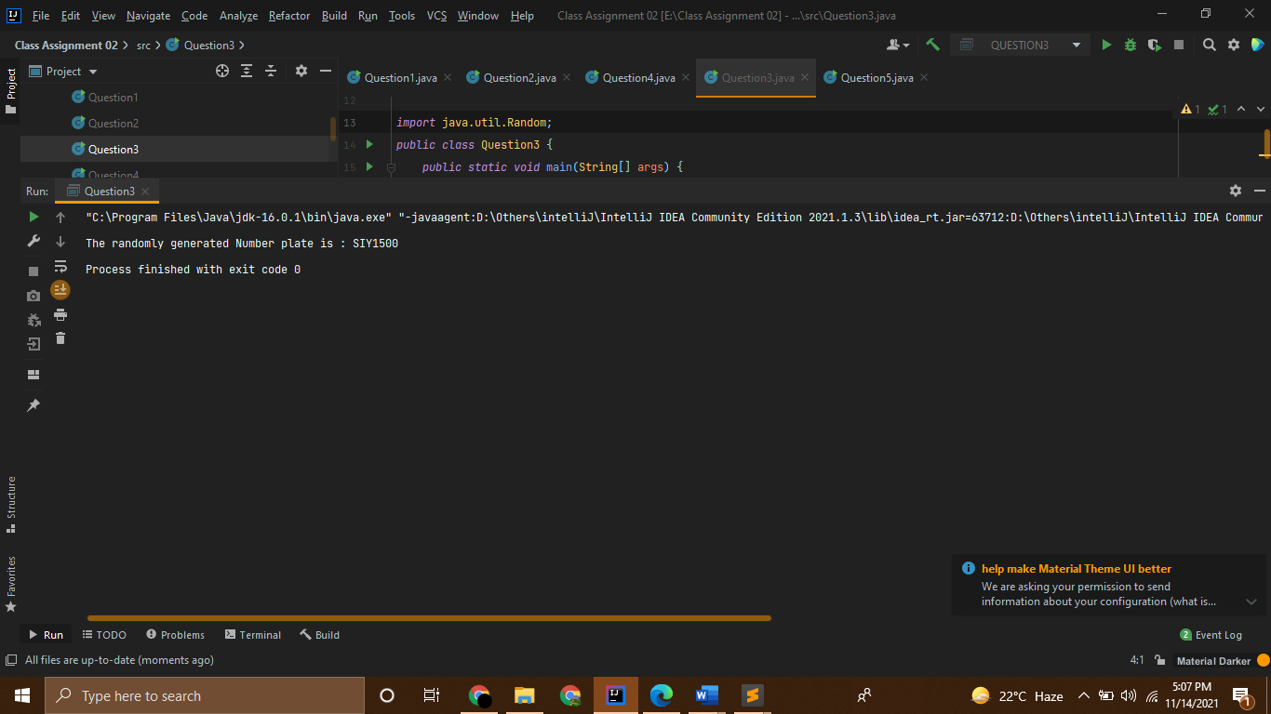

Question 4:

Source Code:

//------------------------------------------------------------

//----------------Shahzaneer Ahmed----------------------------

//////////////////SP21-BCS-087--------------------------------

//--------------CLASS Assignment 02---------------------------

//------------------------------------------------------------

//Question – 4: ______

// Write a program that displays all the leap years, ten per line, from 101 to 2100, separated by

// exactly one space. Also display the number of leap years in this period

public class Question4 {

public static void main(String[] args) {

int count = 0;

for (int i=101; i<=2100;i++){

//Condition for LEap year

if ((i%4==0) && (i%400==0 || i%100!= 0)){

System.out.print(i+ " ");

count= count + 1;

//Printing new line after 10 leap years

if (count%10==0){

System.out.printf("\n");

}

}

}

//Displying total number of leap years

System.out.println("Total leap years are: " + count);

}

}

Screenshot:

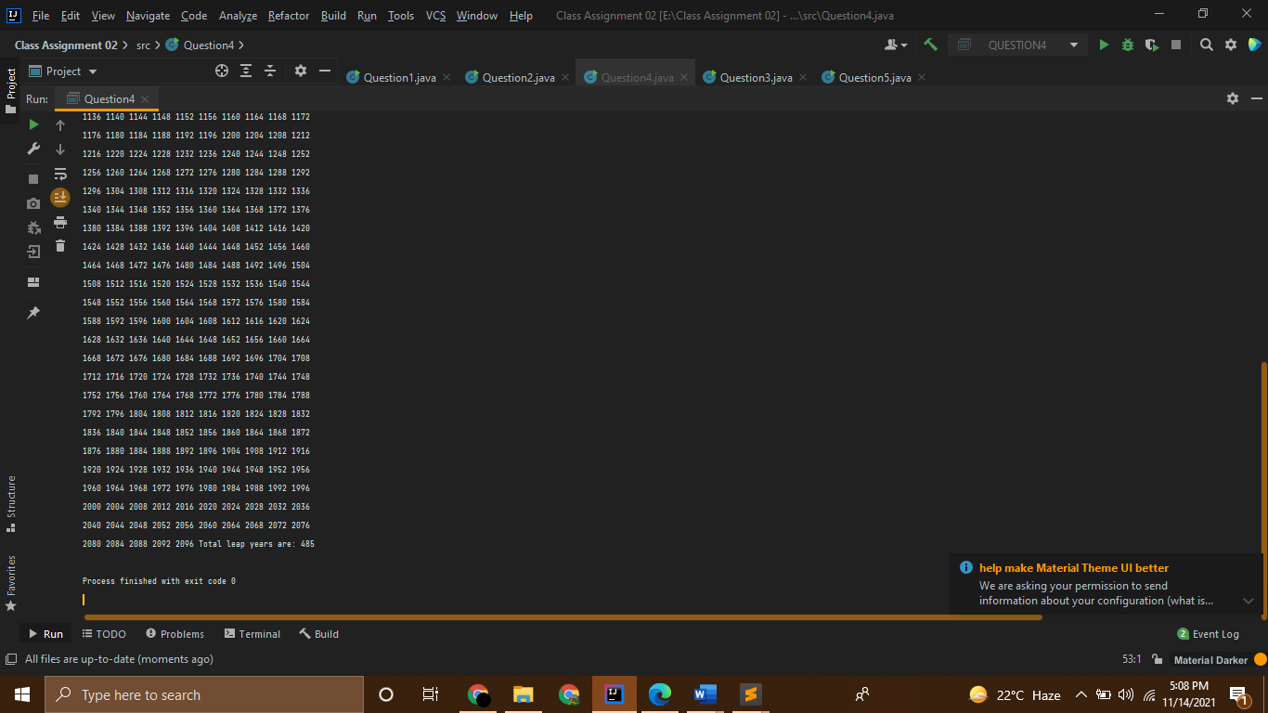

Question 5:

Source Code:

//------------------------------------------------------------

//----------------Shahzaneer Ahmed----------------------------

//////////////////SP21-BCS-087--------------------------------

//--------------CLASS Assignment 02---------------------------

//------------------------------------------------------------

//Question – 5: ______

// Write a program that prompts the user to enter a decimal integer and displays its corresponding

// binary value. Don’t use Java’s Integer.toBinaryString(int) in this program

import java.util.Scanner;

public class Question5 {

public static void main(String[] args) {

Scanner input = new Scanner(System.in);

System.out.println("Enter your decimal value :");

int decimal = input.nextInt();

int num = decimal;

String value = "";

while (num!=0){

int rem = num%2;

value+=rem;

num = num/2;

}

String binary = "";

for (int i = value.length()-1; i>=0;i--){

binary+=value.charAt(i);

}

System.out.println("The binary of given number is :"+binary);

}

}

Screenshot:

